1.0 General Information

Name of the Company Applying for Audit
(Please use the full name of the company e.g. Ltd., Inc, SAC, SA, SARL, BV)

Address of the Company
(Street, postcode, town, province, country, P.O. Box)

Business Registration Number
Audited Site Name and Address
(if different from the company name and address)

Location of the Employee documents
(If the employee documents, including payrolls, attendance, and personal files, are stored in a different location than usual.)

Company’s Legal Representative
(Name, Designation, Email, and Contact Number)

Company’s Contact Person
(Name and Designation If different from above)

Email ID
Contact Number
Site’s Contact Person and or Secondary Contact Person of the Company
(Name and Designation)

Email
Contact Number
Company Website
Scope of the Registration
(Describe your business activities)

Office/Facility Working days and hours

Production Site Working Hours/Shift System
(Including night shift)

Peak Season (only if applicable)

2.0 Audit/Verification Details
 | Audit/Verification Program | Additional Information
 | SMETA Audit  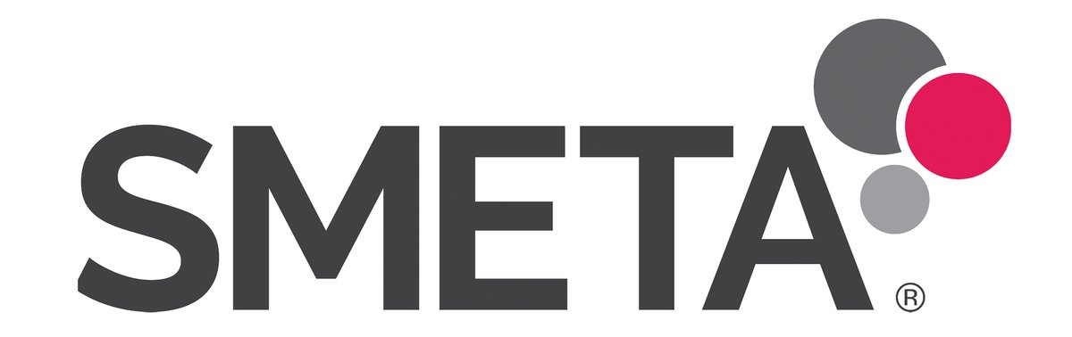  SEDEX Company Reference Number  ZC:  SEDEX Site Reference Number  ZS: | SMETA 2 Pillar Audit [Labour Standards + Health & Safety+ Additional elements of Entitlement to work + Sub Contracting and Home Working + Environment (shortened)]  SMETA 4 Pillar Audit (2 Pillar Audit + Business Practice + Environment)
 | Social & Labour Convergence Program (SLCP)   | Step 1 (Recruitment & Hiring, Working Hours, Wages & Benefits, Worker Treatment, Worker Involvement, Health & Safety, Termination)  Step 2 (Step 1 + Management System)  Step 3 (Step 1 + Step 2 + Above & Beyond)
 | WRAP | Facility ID:
Control Union Ethical Sourcing Audit Tool (Benchmarking the Ethical Trading Initiative Base Code)


Brand Code of Conduct Verification
Brand Name:

Audit/Verification Type | Notification of the Audit/Verification (Some BRANDS need Semi Announced or Unannounced audit as a mandatory requirement)
Full Initial | Announced
Periodic / Renewal /Annual | Unannounced
Full Follow-Up | Semi-announced  Window Period:  Name of the Brand:
Partial Follow-Up | Semi-announced  Window Period:  Name of the Brand:
Other (please describe) | Semi-announced  Window Period:  Name of the Brand:
Desired Audit Date(s)/Period :

 | Indicate the buyer that you are supplying | Was the audit ordered by the brand? (Please select only applicable) | Remarks (If any)
 | Unilever (Unilever RS Program)  (Unilever will no longer accept URSA under Unilever RS) |  | USQS Site ID
 | PepsiCo (PepsiCo SSP program)
 | The Coca-Cola Company (Mutual Recognition)
Marks and Spencer
Clothing & Home Sector

Food Sector

 | Sainsbury’s - Food
Walmart
(Audits after 1st Nov 2025 shall cover the night shift)
Nestle (Nestle RSA program)
(Audit shall be SEMI-ANNOUNCED with 04 weeks window)
 | Tesco
 | Hershey’s RSSP
 | Other (Please list the brands you are supplying)

Brand Nomination
Is there any “Brand Nomination” on selecting the audit house | YES (If yes, please verify that your buyer will  Accept an audit report by the Control Union)  NO

3. Basic Information of Audited Site
Number of Buildings  (On-site) | Office/Admin |  | Dormitory (on-site)
Number of Buildings  (On-site) | Production |  | Wearhouse
Number of Buildings  (On-site) | Other  (Please describe)
Size of the Facility | Land Size
 | Total Floor Size
Name of the  Off-Site Dormitories  (Only applicable) | Distance from the  Site to be audited | Address of the Dormitory
Service/Labour Providers (Ex, Janitorial, Security, Canteen, Local Labour)

Name of the service/Labour  Provider |  | Type of the Service
Details of the Trade Union / Worker Committee

Do you have a Trade Union?  YES NO  Do you have a Worker Committee?  YES NO |  | Names of the Trade Unions and or Worker Committee:

4. Worker Analysis- Excluding Management (Refer to the scheme-specific definition for WORKER before filling this)
 | Local |  |  | Domestic Migrants |  |  | International Migrants |  |  | Other | Total
 | Permanent | Temporary | Agency | Permanent | Temporary | Agency | Permanent | Temporary | Agency | Home Worker | Total
Male
Female
Total

5. Worker Analysis with Dormitory Facility
Dormitory  Name  (Mention the status  Onsite or offsite) | Local workers |  | International Migrant Workers  (Separately mention the country) |  | Domestic Migrant Workers  (Separately mention the State ) |  | Total
Dormitory  Name  (Mention the status  Onsite or offsite) | Male | Female | Male | Female | Male | Female

6. Details of Migrant Workers (including domestic) and Languages spoken by the total workforce

Originating  Countries/States for  total workforce: |  | % of the entire  Workforce originating  From this country/State | Languages  Spoken by  Workers: | % of the entire  Workforce  Speaking this language
Languages  Spoken by  Management: | Language (1)
Languages  Spoken by  Management: | Language (2)
Did the recruitment of migrant workers involve an agency? |  |  | YES  NO
Name of the Agency |  |  | % of the entire migrant workforce by this agency
Percentage of migrant workers in the company who are  provided housing accommodation: |  |  | Domestic:  International :

7. Details of Vendor (only if applicable)
Company Name
Address
Contact Person |  | Designation
Email |  | Contact Number

8. Details for Invoice Arrangements
Company Name
Address
Contact Person |  | Designation
Email |  | Contact Number
Tax/VAT/SVAT Number

9. Additional Information
Has the facility ever been inspected or certified for a social compliance program before by another CB/VB
SA8000 | SMETA | SLCP | BSCI
ETI | WRAP | CT-PAT | Fairtrade
Fairtrade USA | Other
Do you have open NCs from the above-mentioned audit?
YES (If YES, please describe)

NO

Has the facility participated in any other certification programs (Please list here)

I, the undersigned, declare that this application form has been completed truthfully.

Name : | Designation:
Date: | Signature:

